RETENTION SCHEDULER
Project Description

Submitted to:

Prof. Ma. Rowena C. Solamo
Faculty Member
Department of Computer Science
College of Engineering
University of the Philippines, Diliman

Submitted by:
Joaquin, Neil Jonathan A.
Relao, David Paul A.
Simpao, Aldrin

In partial fulfillment of Academic Requirements
for the course
CS 191 Software Engineering I
of the
1st Semester, AY 2014-2015

Unique Reference:
You can find our documents stored at https://github.com/bluenavy/requirements.

Document Purpose:
This document serves as a blueprint for the project. It aims to be a guide or a model for the development process of the actual program and its prototype.

Target Audience:
The target audience of this project consists mainly of the clients, however since the project is useful not only for academics purposes, – it can be used for office work, or simply for daily use – we’d like to focus on the project as a useful tool for students.

Revision Control:
Revision Date | Person Responsible | Version  Number | Modification
8/26/14 | Yno, Neil, David | 1.0 | Initial Document;
8/27/14 | Yno | 2.0 | Added context diagram, and the gist of the document purpose, and a few minor edits.
8/27/14 | Yno | 3.0 | Edit: Document purpose, Target Audience, Entities, Inputs, Outputs, and Functionalities.

Project Title: Retention Scheduler

Description: Every time that the student learns something from class, he can jot down notes directly to this app by noting them in a separate feature like notepad. The dates and time for this are noted as well. Along with this is a student calendar synced with a school year. This can provide the student a planner in which he can note his exam dates and other stuff like quizzes, seat-works, and recitations, with certain topics/lessons that the student needs to focus on for a specific pre-scheduled activity. The student will be reminded of the upcoming activity through pop-up alarms for around 3 times before the activity day on pre-defined hour of each day. More to that, the alarms contain randomized lesson parts or need-to-remember stuff that would be gotten from the notepad for student's retention as a preparation for the activity. Moreover, the students can pile up slides and educational stuff on an archive, for example, for better compilation of his stuff to study.

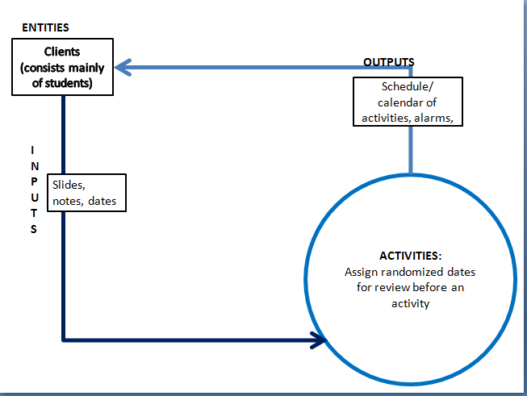
Context Diagram:

Entities:
- User – the target audience, an entity who uses/interacts with the program

Major Inputs:
1. Slides
2. Notes
3. Important dates (eg. Examination days, Quiz days, etc…)

Major Outputs:
1. Create a calendar of activities for the user.
2. Create randomized but relevant pop-ups and alarms.

Major Functionalities:
1. Manage the user’s inputs and dates to remember.
2. Pop-up quizzes on randomized dates.

